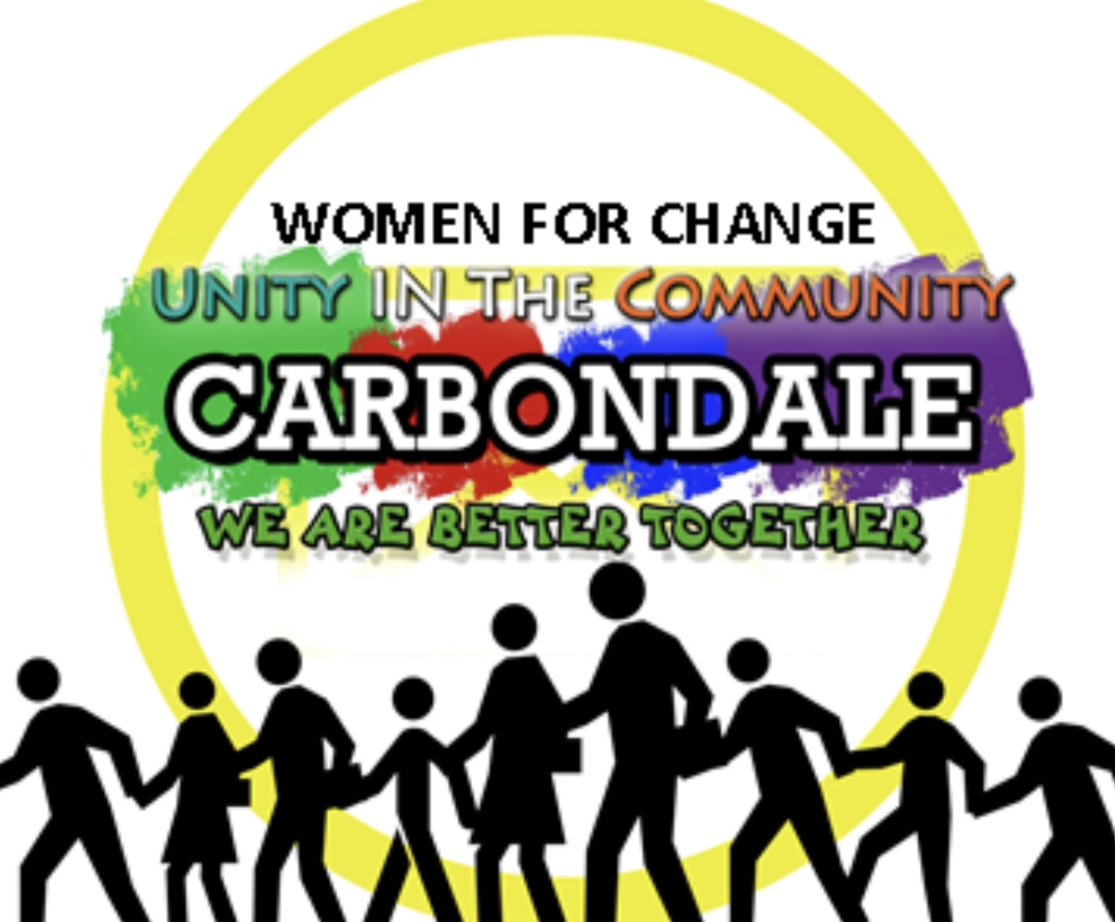
August 1, 2018

Dear Organization,

Women for Change, Unity in the Community Carbondale organization will celebrate our Annual BIG EVENT, a Unity March and a celebration at Attucks Park on September 8th, 2018. The Unity March will bring together diverse groups; religious, environmental, Greek, University and civic organizations in an effort to exemplify our goal. “Unity in the Community”. This year Women For Change is working with PCM, the People’s Climate Movement for Climate, Jobs and Justice.
At 10:15 am. our route will begin at Rockhill Baptist Church on South Marion and Monroe streets marching northward on Marion street to East Willow Street passing the Eurma C. Hayes Center to Attucks Park on North Wall street and East Willow Street. You’re welcome to join us on any leg of the march. Our celebration at the park will begin at 11:00am - 3:00pm featuring speakers from environment and community activist groups, community performances, games and activities for our youth, community group information, and Voter Registration tables.
We are asking all civic minded persons and organization to join together with us for the event. We NEED YOUR HELP! We need the following volunteers: March Marshalls for the March, food servers, playground monitors, and clean up. Lunch will be provided. We are accepting donations for fruit, water, trail mix, cookies and chips. Please let us know about volunteering, items you would like to donate or monetary gifts (we are a 501(c) group) by August 29th. Contact at (618) 203-9617 or (618)203-7065.
If you are interested in ordering a T-shirt @$12, please contact Deborah Woods at (618) 203-6638. Orders need to be placed by August 29th.
The Poster Making Party for the Unity March is Thursday, September 6th, 6pm. at Olivet Freewill Baptist Church, 409 N. Marion Street, Carbondale, Illinois, an opportunity to meet members, volunteers and use your talent at having fun.
Thank you for your cooperation and participation in advance. “WE ARE BETTER TOGETHER”

Sincerely,

Ginger Rye, President ((618) 203-9617
Women for Change
Womenforchange8@gmail.com
Website: Women For Change Carbondale
Facebook: Women For Change Carbondale
Susan Harper, Event Coordinator: (618) 203-7065

